**Experiment 2: Transfer learning**

**For EDGAR dataset Pretrained on IMDB dataset**

**Model1: setting the maxlen to 20**

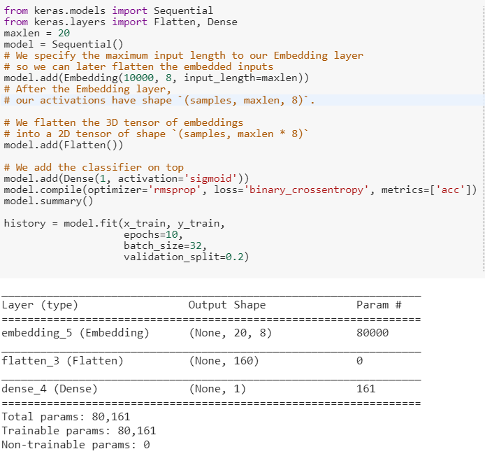

**Result after 10 epochs**

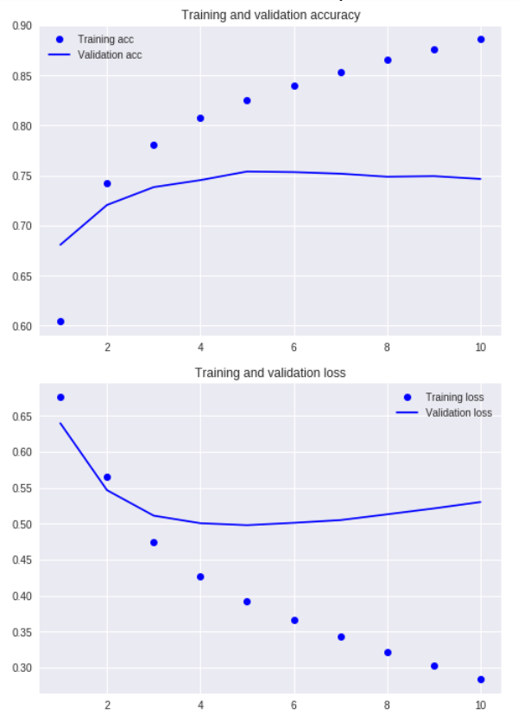

**Model 2: setting maxlen to 100**

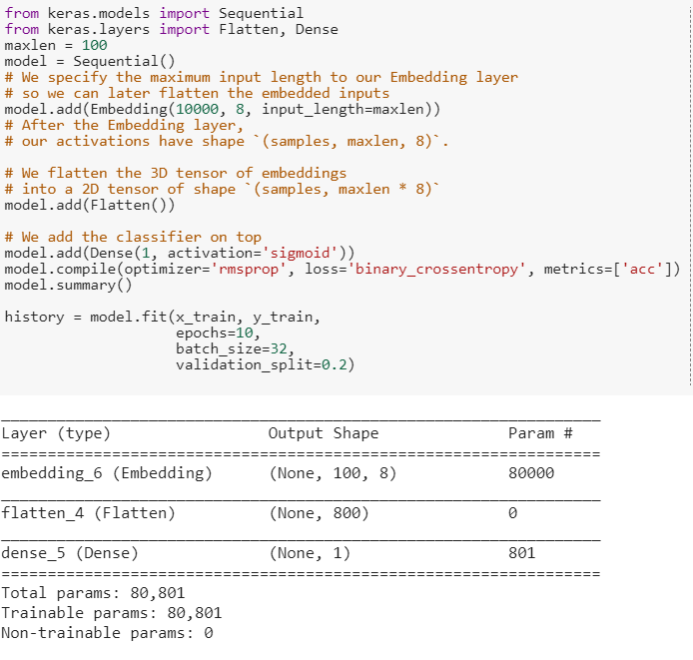

**Resukt after 10 epochs**

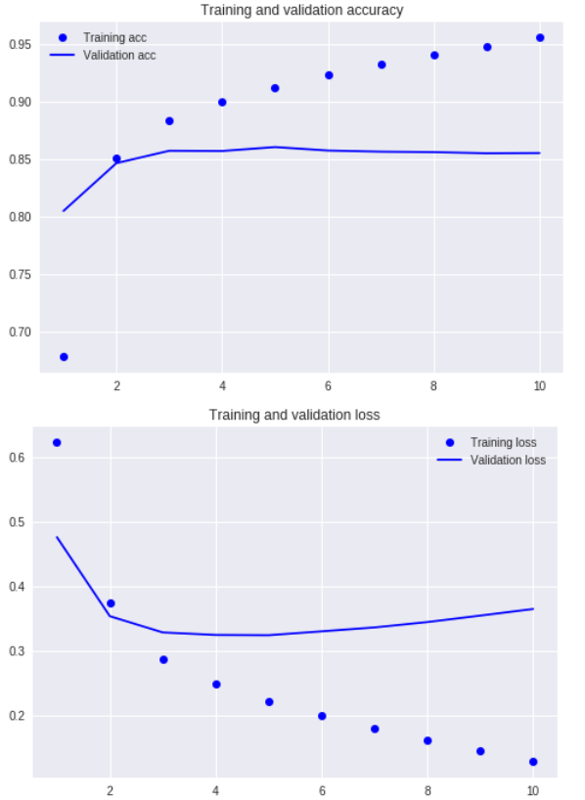

The model with maxlen of 100 had greater accuracy and this model was used to perform the transfer learning

**Model3: Transfer Learning**

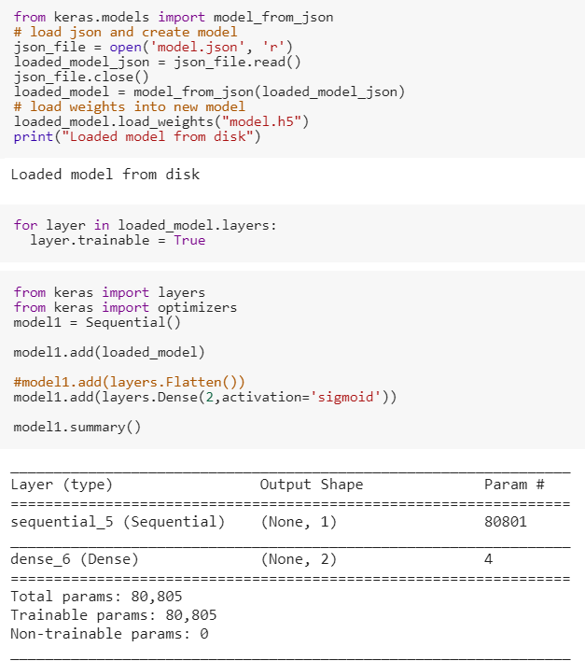

**Result after 25 epochs**

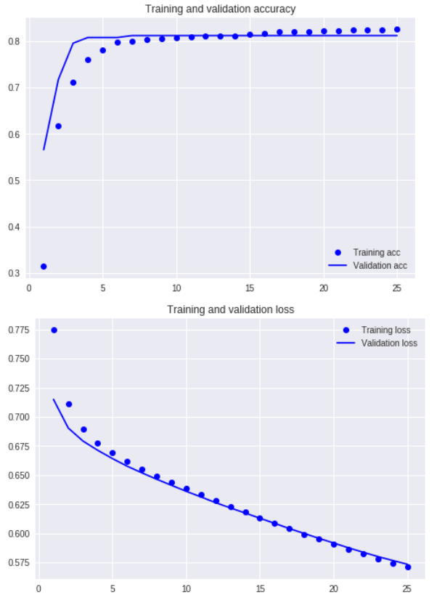

**Confusion Matrix for the validation dataset**

